Volume 24, Issue 1 Spring-Summer 2026
Wellington Woods
Neighborhood News

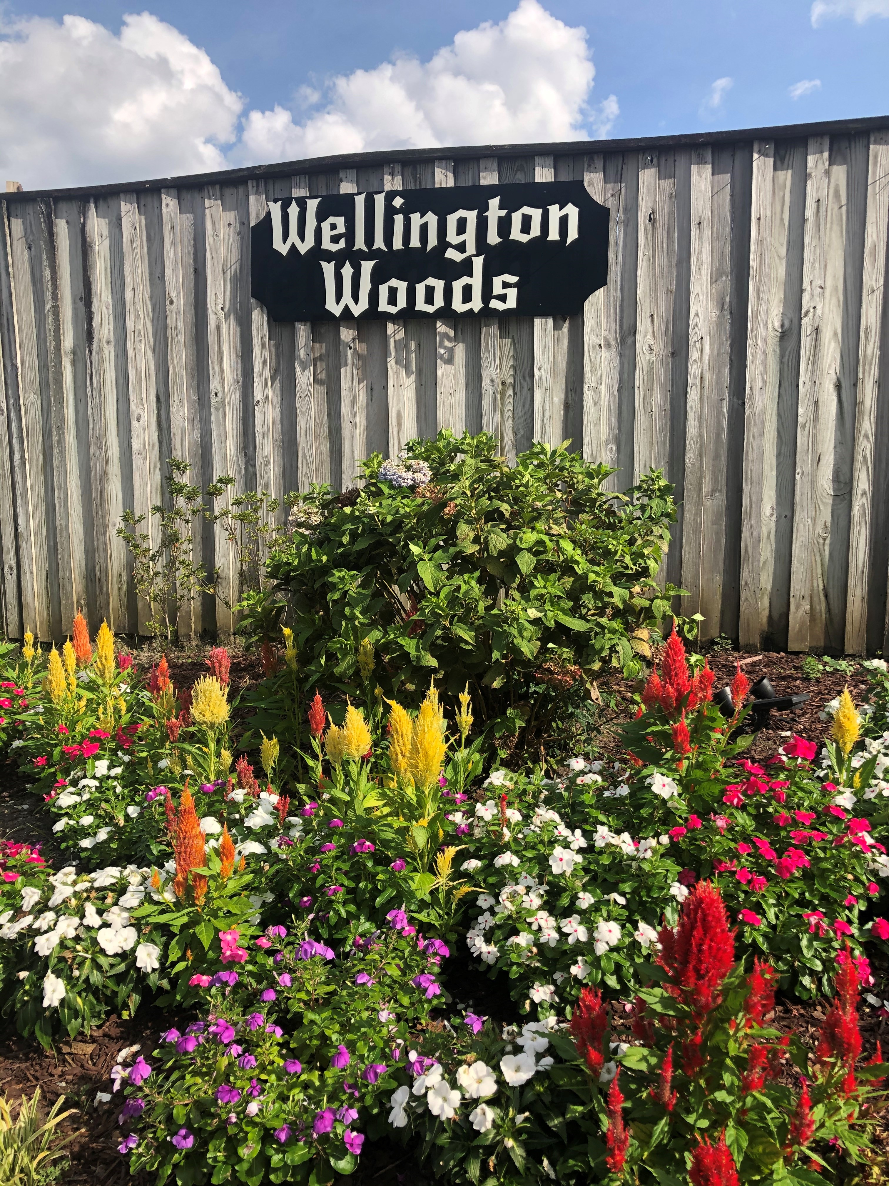


- March 31st - General WWCL Meeting Details forthcoming via email
- April TBD – Spring entrance clean up
Details forthcoming via email
- April 21st - Special Election
- May 15th - WWCL Scholarship deadline pg 2
- May-Sept: Summer WW Neighborhood Driveway Socials happen one Friday evening per month – Dates to be determined. See pg 4
- June 15th - WWCL Dues deadline pg 2

 New property owners or renters ~ Help us update our records so you can receive valuable WWCL updates. Simply email your name(s) and address to wellingtonwoodscivicleague.com
Subject: New Neighbor

Stay connected with Wellington Woods
WWCL website:
http://wellingtonwoodscivicleague.com/
Join Next-door:
https://nextdoor.com

Friend us on Facebook:
https://www.facebook.com/wellington.woods.5

Virginia Beach, VA 23454
Mission Statement: Our mission is to have a unified voice that protects and enhances the value and living enjoyment of our neighborhood….and of course,
fun times to make a strong neighborhood.

Message from WWCL Vice President
Neighbors,
Spring of 2026 has arrived and it’s planning time for WWCL. Before we look too fast ahead, I’d like to reflect about accomplishments made by your support and volunteers on WWCL.
- Over $8,500 in scholarship awards has been granted to those in the Wellington Woods community, advancing into higher education beyond high school. This is from an “optional” donation with dues payments.
- A positive bank account has made significant growth from hundreds to over $4,000 in the general fund currently and more growth in the coming years.
- The signs on the southern entrance were purchased.
- One of our very generous neighbors helped with installing and getting the new lamp fixtures on the entire median.
- We were able to clean, repoint and replace over 200 bricks at southern wall entrances to preserve the integrity of our entrance for many years to come.
- New pet waste stations have been established with ongoing bag replacements and neighborhood service volunteers ensuring trash is disposed properly.
- A lovely book library donated by one of our neighbors, has allowed for those within the neighborhood to share their favorite reads.
- We had 3 successful socials in 2025 with a combined attendance of 250+

Continued on page 2

Message from Vice President (continued)  - A large success for WWCL. After many letters and 40 emails later resulted in 2 entrance lamps installed and paid permanently by Dominion Power and Virginia Beach.  - Tons of giving volunteers graciously donated time and efforts.  - Compliments of U.S Flags and Signals, most recently a new “Premium” U.S.A. Flag that has every star embroidered to give our best to all our service members.  Above are just a few items that stand out. Hopefully this year, with approval, we can invest and fund our landscape and maintenance on southern entrances.  Additionally, I hope we have sufficient support in our scholarship program to fund several well-deserving seniors in our neighborhood.  Lastly, I hope more people can become involved with WWCL. We are pleased to have Chris Lizette as our new Treasurer and appreciate Sarah Cherry for her board service over the past couple of years. Involvement is easy and really doesn’t take much time when you have a good team. Come out March 31st to learn more as we plan for 2026!  Paul Brannock  WWCL Vice President    WELLINGTON WOODS  REAL ESTATE MARKET  For Sale: Nothing on the market  Recently Sold:  725 Earl of Chesterfield Ct 4/2.5 2,614 sq ft  3/2/26 $580, 000  Information obtained from REDFIN and Zillow websites.  Wecome our newly elected Treasurer,  Chris Lizette of Earl of Chatham Lane  Meet the Lizette Family!  The Lizette family is happy to call the Wellington Woods neighborhood home. Chris works in Information Technology and Jacki is a dedicated nursing Case Manager who spends her days caring for others and supporting her community.  Their two energetic sons, Lucas and Noah, both attend Trantwood Elementary School and currently enjoy playing soccer whenever they get the chance. Their older sister, Katie, is currently in college and enjoys watching F1 racing when she can!  When they are not busy with school or work, the whole family loves being outdoors. They especially enjoy swimming, camping, and spending time together.  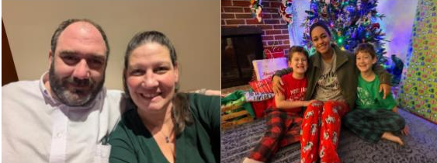  Treasurer’s Report  Treasurer’s report as of February 2, 2026  $4,166.88 General Fund | $258 Scholarship Fund  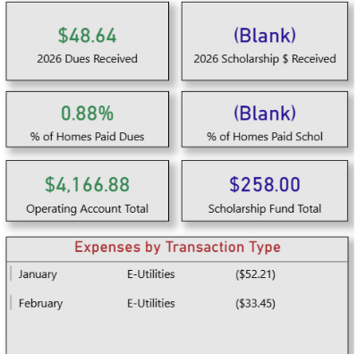  For questions or expense details please email the treasurer at wwcltreasurer@gmail.com  What is a Civic League?  A "civic league" is a non-profit neighborhood organization focused on improving the quality of life in a specific area through community engagement, addressing local issues, and providing a voice for residents in local government. At a national level, the National Civic League promotes civic engagement across communities and works with local governments and institutions.  Common functions of civic leagues  - Community advocacy: They act as a collective voice for neighborhoods on city-wide issues.  - Neighborhood improvement: They work to improve the quality of life through local projects and initiatives.  - Information sharing: They often serve as a hub for news, community insights, and resources for residents.  - Local event support: They help organize and promote community events, fostering connection among neighbors.  - Education: They may provide educational programs to help residents become more informed and engaged.    Driveway Socials  We’re looking for neighbors interested in hosting one of this year’s neighborhood socials! You can host in your driveway or team up with a few neighbors to organize one in a court or on a dead-end street. Hosts may choose any Friday evening from May through September.  We simply ask that hosts provide a few tables and basic paper products. If you’re interested in hosting.  In addition, if you would like to help with other neighborhood social events ex; community yard sale, summer activities, book club, yard of the month, fall festival etc. please reach at to Alicia Shepard 757-450-4448.  Great Neck Recreation Center Modernization:  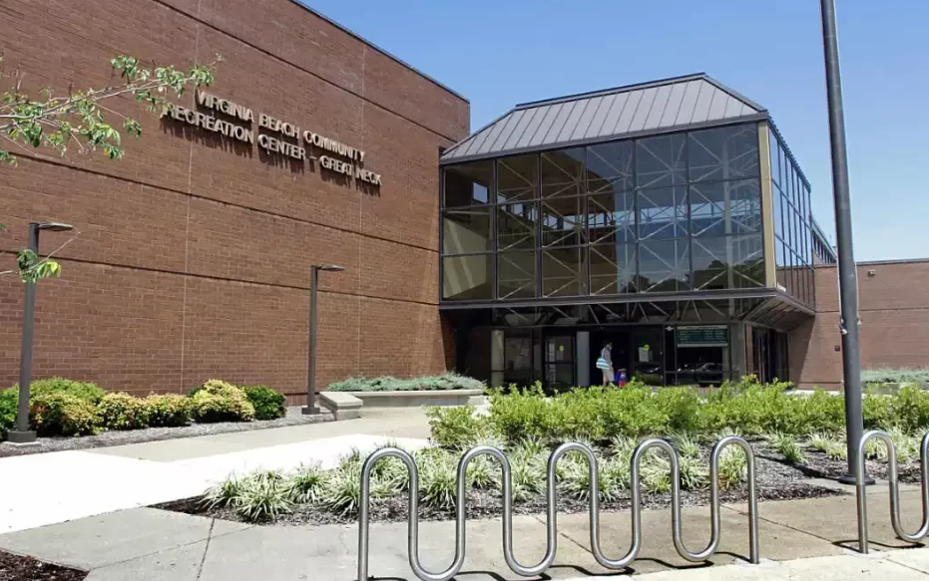  The City of Virginia Beach is undertaking a feasibility study for the Great Neck Recreation Center to assess potential future improvements, including renovation and/or expansion, that will meet the growing needs of our community.  You and your household can play an important role as the city moves forward with this exciting project. Please give us a few minutes to share your thoughts regarding your household’s priorities for future improvements. Even if you do not currently use, or plan to use, the Great Neck Recreation Center, we would still appreciate hearing from you. A survey link will be published here soon.    Neighborhood Clean-up and Beautification will take place in April. Date and time will be discussed at the General Meeting on March 31st.  Are you doing outdoor home improvement?  For your safety and to minimize disruptions to utility services you need to call Miss Utility to have any utility lines that might be in the area of your work marked so you can avoid damaging them or possibly injuring yourself. A representative from each utility company with service that might be affected by your work will mark the approximate location of their underground lines. There is no charge for this service!  48 Hours Before You Dig...  Call 811 or 1-800-552-7001. Failure to notify Miss Utility before you dig could make you liable for the cost of any repairs should you damage a utility service. | 2026 CIVIC LEAGUE DUES DRIVE    Dues help the Civic League upkeep, repair and improve our neighborhood. As well as host fun activities throughout the year.  To pay your $25 membership dues, you have options:  - Pay by QR code or online Pay Now button on the WWCL website; http://wellingtonwoodscivicleague.com/  - Mail/drop off to Chris Lizette, Treasurer at 941 Earl of Chatham Lane. Dues form is located on the last page of this newsletter.    2026 High School Scholarship Application  If your high school senior is planning to continue their education immediately upon graduation to any post-secondary institution, they can apply for the WWCL scholarship by going on our website “Scholarship Program” tab at wellingtonwoodscivicleague.com.  Application Deadline is May 15, 2026. Scholarship recipients will be notified by May 22, 2026.  If you would like to donate to the WWCL Scholarship fund you can do so via QR, online at http://wellingtonwoodscivicleague.com/    or when you pay your dues.  Thank you for your donation to support our neighborhood students’ future.  NEW ENTRANCE LIGHTING IMPROVEMENTS  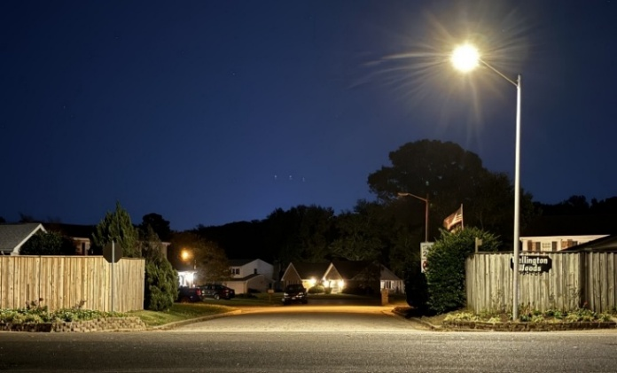  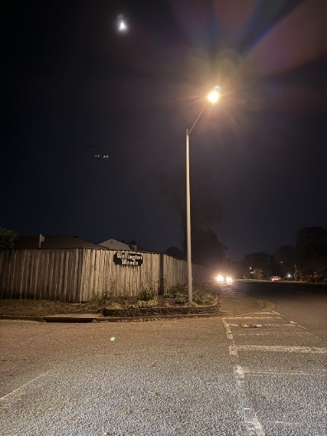  Thanks to the support of Councilman Worth Remick, the WWCL successfully completed this upgrade. The new streetlights at the intersections of Great Neck Rd & N. Plantation Rd and Great Neck Rd & N. Wolfsnare Dr were installed in November and January.    We would like to extend our sincere thanks to our past treasurer, Sarah Cherry, for the past 2 years of dedicated service to the Civic League. Your time, care, and commitment to responsibly managing our finances have helped keep our organization strong and running smoothly. We are truly grateful for the countless hours you contributed behind the scenes on behalf of our neighborhood.  Thank you to the Lord Seaton Circle neighbors for hosting the 2025 Fall Festival.  This is always a well-attended and fun event for everyone.  We look forward to 2026’s Fall Festival.  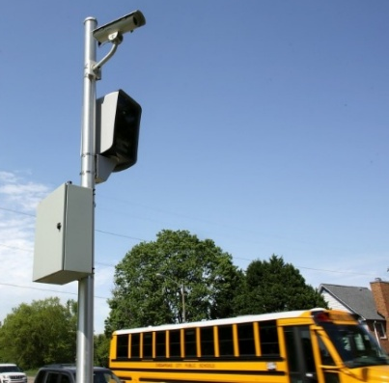  School Speed Zone Camera Enforcement Program  Beginning in February 2026, automated cameras will be installed in designated school zone area to provided added safety for students and pedestrians.  There is a 30-day warning period when the cameras are initially activated. Citations and fines will be mailed beginning on March 19.  We currently have one just down the road on Great Neck Road at Great Neck Middle School/John B. Dey Elementary School.  Enforcement occurs only when the school zone’s flashing lights are on. The cameras operate during the times when children are arriving or leaving school. They are inactive outside of the flasher periods, including: Holidays, Staff days, Weather related closures, delays, or early dismissals. The system is programmed to match the school calendar exactly. Violations will incur a $100 fine.    Michael and Kimthanh Lê Planetarium  Guiding the curiosity of Hampton Roads and beyond, the Michael and Kimthanh Lê Planetarium serves as a beacon of exploration, education, and inspiration. With a commitment to fostering a deeper understanding of the cosmos, we strive to ignite wonder and a lifelong passion for astronomy through captivating, immersive experiences. Our mission is to connect people of all ages to the mysteries of the cosmos and empower them to explore, discover, and appreciate the beauty of the Universe in which we live. Weekly shows are $5/person.  4501 Elkhorn Ave |Norfolk, VA, 23529 757-683-3865 |planetarium@odu.edu  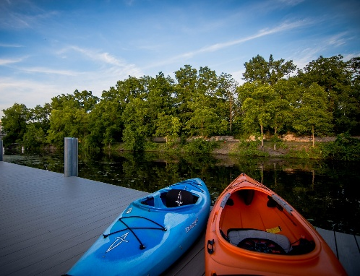  Kayak Rental Information  Explore the water with ease at select parks! Our self-service kiosks function like vending machines. Just scan the QR code, download the app, and follow the prompts to rent a kayak or purchase an unlimited rental membership.  Each rental includes a paddle and a personal flotation device (PFD) - all you need to bring is sunscreen and water. Rentals are available to individuals 18 and older.  How It Works  Note: Submitting a photo during the return process is required. Failure to upload may result in additional charges.  - Download the App  Create your account and get started!  - Unlock Your Equipment  Scan the QR code at the station to unlock your kayak. Paddles and lifejackets are included.  - Enjoy Your Paddle!  Always wear your lifejacket while on the water.  - Return your Equipment  Return your equipment to the station. In the app, select "Unlock" to return it, then choose "End Rental.”  Don’t forget to upload a photo through the app to avoid additional charges.  Kiosk Locations  - Munden Point Park  - Lake Lawson/Lake Smith Natural Area  - Stumpy Lake Natural Area  Rental Prices  - Unlimited Rental Membership: $99/year  - 2-hour rental: $25  - Additional hours thereafter: $15/hour

Wellington
Woods
Civic
League


Thank you for your continued support!
2026 WWCL ANNUAL DUES INVOICE
Your membership dues support the betterment of the Wellington Woods neighborhood. We fund entrance electricity, maintenance of common areas, family activities and capital improvements.
Current Annual Dues are $25.00 per household (Owners & Renters). The 2026-27 membership year runs April 1, 2026 to March 31, 2027
Due Date: June 15, 2026
Wellington Woods also offers a scholarship fund which awards a college scholarship to a high school senior in our neighborhood. This is based upon applications and selection by the WWCL Scholarship Committee.
You can now pay dues and contribute to the
Scholarship fund on-line at www.wellingtonwoodscivicleague.com or QR codes below ***
You can also pay via check. Please make your checks payable to WWCL
If paying by check you can give it to your block coordinator, drop off or mail to:
WWCL Treasurer 941 Earl of Chatham Lane, Virginia Beach, VA 23454
(Please include this form with all check payments)
Annual Dues Amount $25 plus Annual Scholarship Fund $ __________(optional):
Total Amount enclosed: $__________
NAME: ____________________________________________________________________
ADDRESS: _________________________________________________________________
PHONE: _____________________________E-Mail:**______________________________
** This is our primary means of communicating with our members with up-to-date news & information **


***2 separate transactions: one under members and one under scholarship.
On-line payments include an automated receipt.

